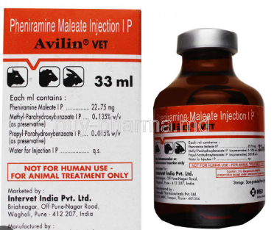
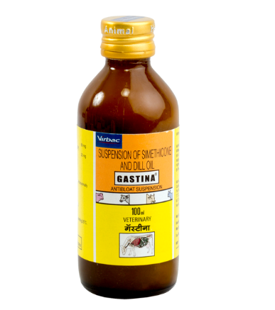
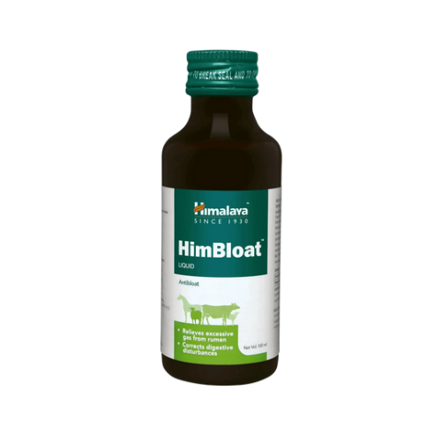
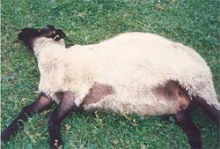
Video link https://srikanthmekala500.github.io/my-website-Sheep/

Vegetable oil / Coconut oil: 50–100 ml orally
Turpentine oil: 10–15 ml mixed with oil (traditional use)
Sodium bicarbonate: 10–20 g in water orally

Bloating is a common and life-threatening condition in sheep caused by excess gas buildup in the rumen
Causes
- Sudden change in feed
- Fresh green grass, alfalfa, clover
- Wet fodder / legume-rich diet
- Overeating concentrates or grains
- Poor-quality roughage
Clinical Signs
- Left side abdomen swollen
- Restlessness, kicking belly
- Grinding teeth
- Breathing difficulty
- Animal stops eating
Key point: In bloat, the LEFT side (rumen area) becomes visibly distended like a drum.
Exact Rumen Location
- Left side of abdomen
- Just behind the ribs, in front of the hip bone

Option 1: Gastina suspension – 20 ml orally
Best for: Mild to moderate / early bloat (especially frothy bloat)
Why:
- Simethicone breaks gas bubbles
- Dill oil improves rumen movement
Dose:
- Adult sheep: 20 ml orally (can repeat after 6–8 hrs if needed)
- Lambs: 5–10 ml orally

Option 2: Himbloat + Avil injection
Best for: Moderate to severe bloat with pain, allergy, or respiratory distress
Why:
- Himbloat: herbal carminative, reduces gas & improves rumen motility
- Avil (Pheniramine): controls allergic reaction, reduces shock
Typical use:
- Himbloat: as per label (oral)
- Avil: IM injection (dose as per body weight)
If need use the
Avil injection + Gastina suspension in Option 1

Treatment Protocol (Field Practice)

Bloating treatment in sheep video

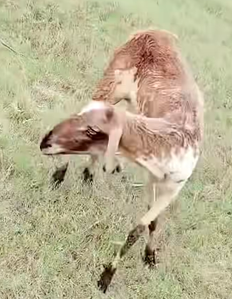
Trypanosomiasis in sheep
Treatment Protocol (Field Practice)
Key Clinical Signs
- High fever (intermittent)
- Severe anemia (pale gums, weakness)
Neurological signs (important):
- Circling
- Head pressing
- Incoordination
- Aggressive or “crazy” behavior

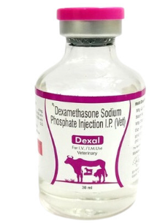
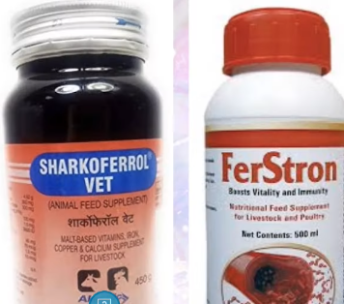
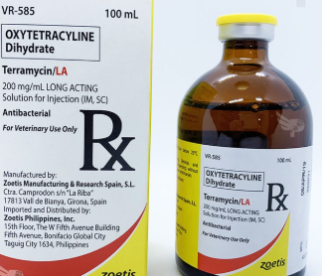
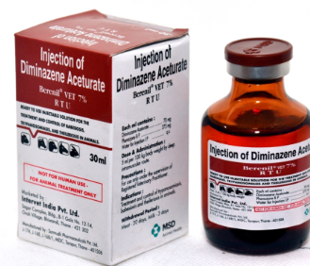
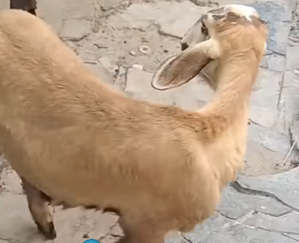
Video link and Treatment Protocol
https://srikanthmekala500.github.io/my-website-Sheep/
Primary drug
- Diminazene aceturate – single deep IM injection (dose as per body weight)- kills parasite
Supportive therapy
- Dexamethasone (for CNS signs & inflammation, dose as per body weight)) - saves brain & nerves
- Oxytetracycline (Terramycin) – 3 days (controls secondary infections, dose as per body weight)) - protects from secondary infections
If need
Iron + Vitamin B12 injection → for anemia
Liver tonic (oral) → 5–7 days
B-complex injection → alternate days × 3 doses Glucose / Electrolytes → if weak

How Infection Spreads
- Bites of infected flies
- Contaminated needles/instruments
- Blood contact between animals

Trypanosomiasis (also called Surra) is a blood-borne parasitic disease of sheep caused by Trypanosoma and transmitted mainly by biting flies (e.g., tsetse, tabanid flies).

